

FRONT END – PART 2
UNDERSTANDING DOM

(Accessing Elements)

In this HTML file, we have many elements that we will access with different document methods.

When we render the file in a browser, it will look similar to this:

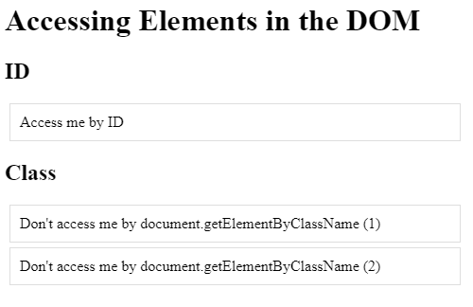
1. Now you have to access a single element in the DOM by its unique ID and change the border property to green.
2. We have two elements with a demo class in the given file. Access elements and put them in a variable. for accessing the element you can't use getElementsByClassName.
3. You have now selected every element on the page that has a demo class and changed the border property to blue.
4. You must change the second text element to "Second Elements of Class".

Expected Output:





